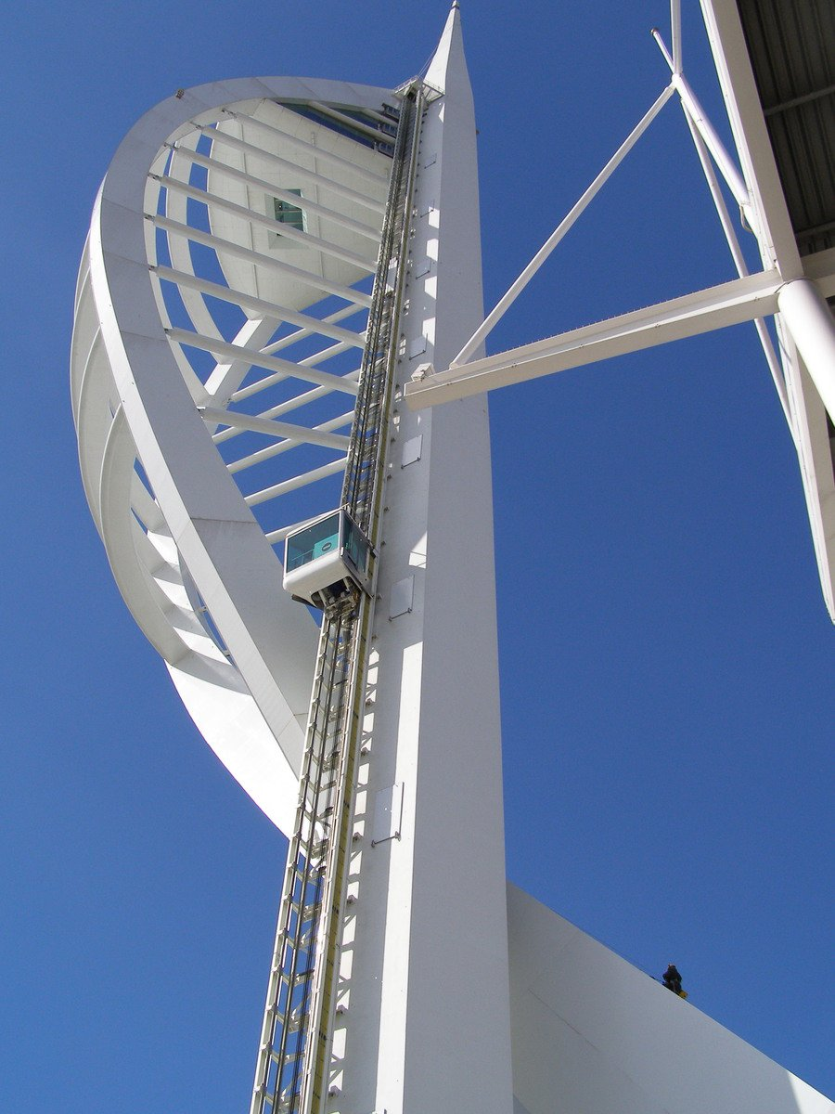
Gunwharf Quays &Portsmouth
Tuesday 1st December
Coach leaves9.30- 6.00pmreturn coach
£18
For further information please contact:
The Gill Nethercott Centre
01256 896270
gillnethercottcentre@btconnect.com
*********

