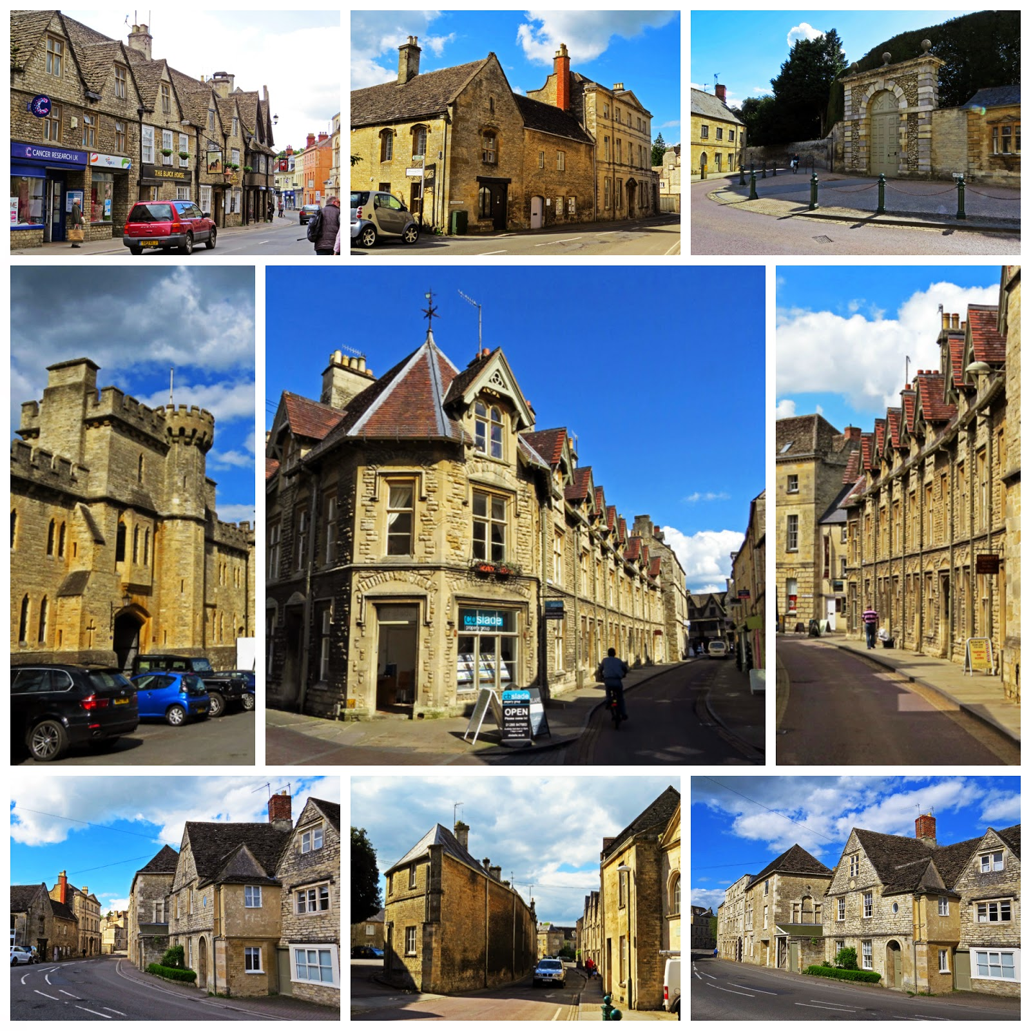

Cirencester

Tuesday 3rd November

Coach leaves 9.30 – 6.00pm

£20

For further information contact:

The Gill Nethercott Centre

01256 896270

gillnethercottcentre@btconnect.com