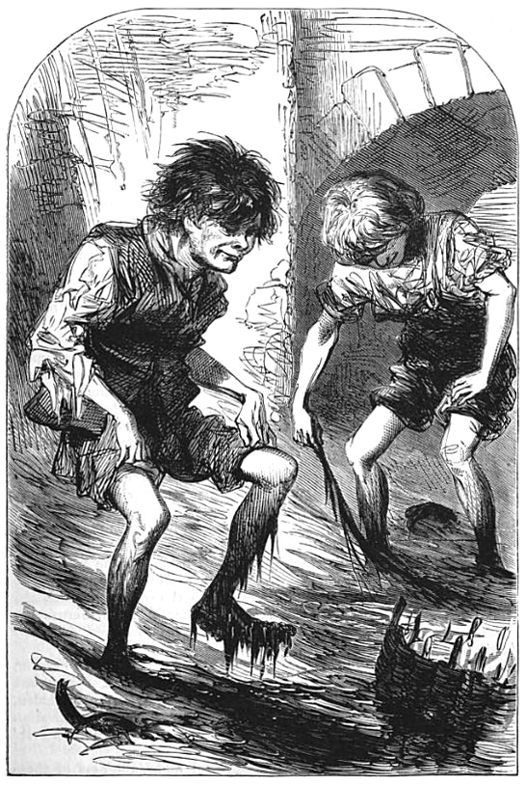
Mud-larking
Description
A mudlark is someone who scavenges in river mud for items of value, a term used especially to describe those who scavenged this way in London during the late 18th and 19th centuries. Wikipedia
Or
In 1977 a colleague at the Natural History Museum asked
Simon Moore
if he’d like to accompany him to search the Thames foreshore for ancient relics.
Already with an interest in antique eating and folding cutlery , Simon readily agreed and shortly afterwards acquired a rare medieval pocket knife.
He also started acquiring other eating knives, spoons and the occasional fork as well as pins, thimbles, an intact wine bottle c1670 ,bellarmine bottle, pilgrim signs and many other relics of everyday life back then
Come and hear Simon talking about his adventures on
Thursday 4th June 2020
7.30pm
£5
For further information please contact:
gillnethercottcentre@btconnect.com 01256 896270

