[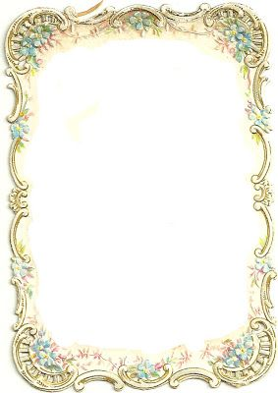](https://www.google.co.uk/url?sa=i&rct=j&q=&esrc=s&source=images&cd=&ved=2ahUKEwjV2vrr8OvjAhW18uAKHR4OBb4QjRx6BAgBEAU&url=https%3A%2F%2Fwww.pinterest.com%2Fpin%2F1266706122455749%2F&psig=AOvVaw2rfiuijm12fBzHzM7A5kDg&ust=1565099609542284)

Antique and Collectables

VALUATION

DAY

SUNDAY 6TH OCTOBER

10.00- 3.00pm

On Sunday 6th October you are invited to join representatives from

Woolley and Wallis -Salisbury Salesroom

who will be in attendance at the Gill Nethercott Centre for a Valuation Day .

Specialists in Jewellery, Asian Art, Pictures ,Ceramics and Glass will be with us from 10.00 – 3.00pm .

There will be a charge of £2 per item valued.

Refreshments will be available on the day.

For further information please contact:

The Gill Nethercott Centre

01256 896270

gillnethercottcentre@btconnect.com