[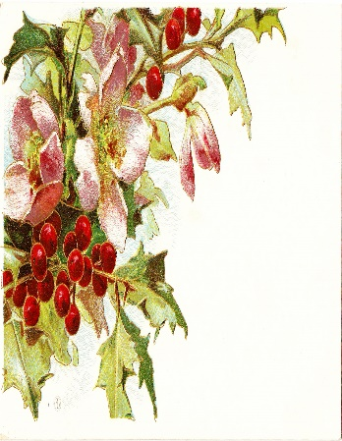](https://www.google.co.uk/url?sa=i&rct=j&q=&esrc=s&source=images&cd=&cad=rja&uact=8&ved=2ahUKEwio3vSv8YDeAhXjzoUKHeAjC9sQjRx6BAgBEAU&url=http://catnipstudiocollage.blogspot.com/2011/10/free-vintage-clip-art-christmas-holly.html&psig=AOvVaw3L0DKxC2dPruQ4pMMQ6l00&ust=1539433076057996)[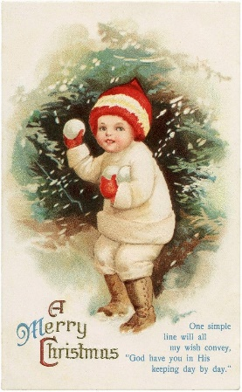](https://www.google.co.uk/url?sa=i&rct=j&q=&esrc=s&source=images&cd=&cad=rja&uact=8&ved=2ahUKEwiJnpbX8YDeAhVChRoKHRIfBEsQjRx6BAgBEAU&url=http://wiceimage.pw/free-postcard-images-vintage-Surfing-for-Freebie-Christmas.html&psig=AOvVaw3L0DKxC2dPruQ4pMMQ6l00&ust=1539433076057996)[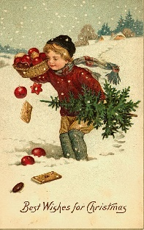](https://www.google.co.uk/url?sa=i&rct=j&q=&esrc=s&source=images&cd=&cad=rja&uact=8&ved=2ahUKEwiRiL7s8YDeAhVCPBoKHfgVBYEQjRx6BAgBEAU&url=http://mariafresa.net/single/1990281.html&psig=AOvVaw3L0DKxC2dPruQ4pMMQ6l00&ust=1539433076057996)[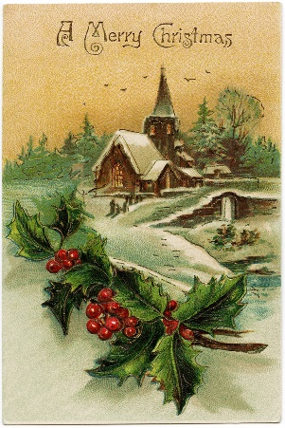](https://www.google.co.uk/url?sa=i&rct=j&q=&esrc=s&source=images&cd=&cad=rja&uact=8&ved=2ahUKEwib4dCJ8oDeAhUGxxoKHcYfC20QjRx6BAgBEAU&url=https://www.pinterest.de/pin/258464466094050299/&psig=AOvVaw3L0DKxC2dPruQ4pMMQ6l00&ust=1539433076057996)[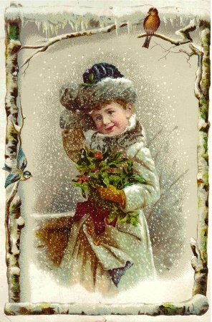](https://www.google.co.uk/url?sa=i&rct=j&q=&esrc=s&source=images&cd=&cad=rja&uact=8&ved=2ahUKEwjJzfj98YDeAhWyxYUKHWh0DcAQjRx6BAgBEAU&url=http://www.karenmillerbennett.com/holidays/merry-christmas-from-karens-chatt/&psig=AOvVaw3L0DKxC2dPruQ4pMMQ6l00&ust=1539433076057996)[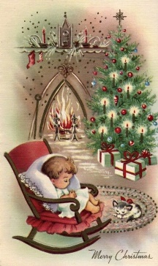](https://www.google.co.uk/url?sa=i&rct=j&q=&esrc=s&source=images&cd=&cad=rja&uact=8&ved=2ahUKEwir0PeX8oDeAhWpy4UKHVglBpUQjRx6BAgBEAU&url=https://www.pinterest.com/pin/374572893990296036/&psig=AOvVaw3L0DKxC2dPruQ4pMMQ6l00&ust=1539433076057996)[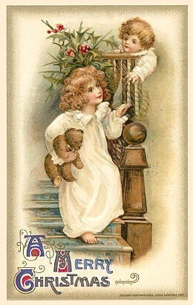](https://www.google.co.uk/url?sa=i&rct=j&q=&esrc=s&source=images&cd=&cad=rja&uact=8&ved=2ahUKEwinlfrL8YDeAhULvxoKHWJvB2oQjRx6BAgBEAU&url=https://festival-collection.com/vintage-christmas-cards-clip-art/&psig=AOvVaw3L0DKxC2dPruQ4pMMQ6l00&ust=1539433076057996) [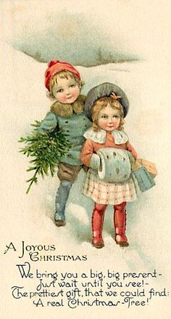](https://www.google.co.uk/url?sa=i&rct=j&q=&esrc=s&source=images&cd=&cad=rja&uact=8&ved=2ahUKEwjJ_8ne8YDeAhVHCxoKHVKNBPUQjRx6BAgBEAU&url=https://www.pinterest.com/pin/98727416809719109/&psig=AOvVaw3L0DKxC2dPruQ4pMMQ6l00&ust=1539433076057996) [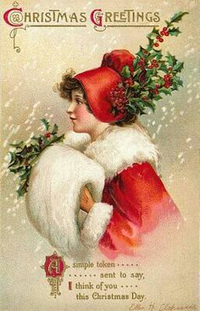](https://www.google.co.uk/url?sa=i&rct=j&q=&esrc=s&source=images&cd=&cad=rja&uact=8&ved=2ahUKEwj787HX9oDeAhWNxoUKHaIXC8AQjRx6BAgBEAU&url=https://www.pinterest.com/Ophelia1021/victorian-christmas/&psig=AOvVaw3L0DKxC2dPruQ4pMMQ6l00&ust=1539433076057996) [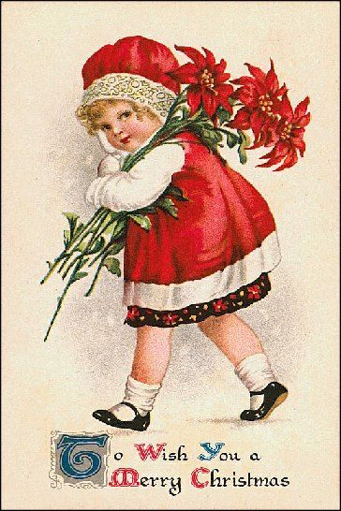](https://www.google.co.uk/url?sa=i&rct=j&q=&esrc=s&source=images&cd=&cad=rja&uact=8&ved=2ahUKEwjU55PO_4DeAhWm34UKHb5gBFgQjRx6BAgBEAU&url=https://ar.pinterest.com/pin/699254279614924550/&psig=AOvVaw3L0DKxC2dPruQ4pMMQ6l00&ust=1539433076057996) [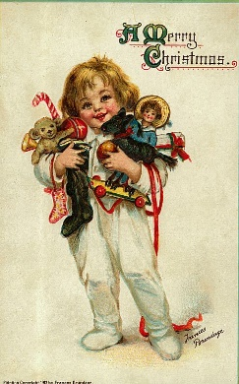](https://www.google.co.uk/url?sa=i&rct=j&q=&esrc=s&source=images&cd=&cad=rja&uact=8&ved=2ahUKEwiB8bm494DeAhUHuRoKHc4FBogQjRx6BAgBEAU&url=https://hubpages.com/holidays/antique-toys-vintage-christmas-cards&psig=AOvVaw3L0DKxC2dPruQ4pMMQ6l00&ust=1539433076057996) [](https://www.google.co.uk/url?sa=i&rct=j&q=&esrc=s&source=images&cd=&cad=rja&uact=8&ved=2ahUKEwiB8bm494DeAhUHuRoKHc4FBogQjRx6BAgBEAU&url=https://hubpages.com/holidays/antique-toys-vintage-christmas-cards&psig=AOvVaw3L0DKxC2dPruQ4pMMQ6l00&ust=1539433076057996)[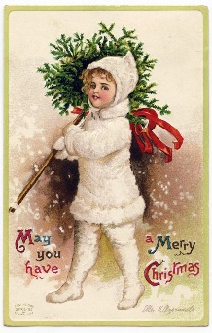](https://www.google.co.uk/url?sa=i&rct=j&q=&esrc=s&source=images&cd=&cad=rja&uact=8&ved=2ahUKEwjK1LO_8YDeAhUMzoUKHWXfCMUQjRx6BAgBEAU&url=https://thegraphicsfairy.com/100-free-christmas-images/&psig=AOvVaw3L0DKxC2dPruQ4pMMQ6l00&ust=1539433076057996) [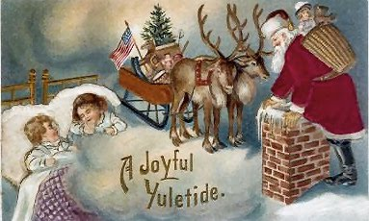](https://www.google.co.uk/url?sa=i&rct=j&q=&esrc=s&source=images&cd=&cad=rja&uact=8&ved=2ahUKEwj2gJSb94DeAhUH0xoKHYepDkAQjRx6BAgBEAU&url=http://harvesthouseprimitives.blogspot.com/2009/11/free-vintage-christmas-graphics.html&psig=AOvVaw3L0DKxC2dPruQ4pMMQ6l00&ust=1539433076057996) [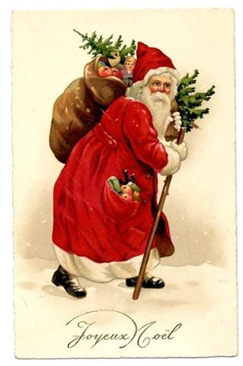](https://www.google.co.uk/url?sa=i&rct=j&q=&esrc=s&source=images&cd=&cad=rja&uact=8&ved=2ahUKEwjcx8ym9oDeAhWozoUKHaRVBmQQjRx6BAgBEAU&url=https://www.pinterest.com/pin/505810601874022069/&psig=AOvVaw3L0DKxC2dPruQ4pMMQ6l00&ust=1539433076057996) [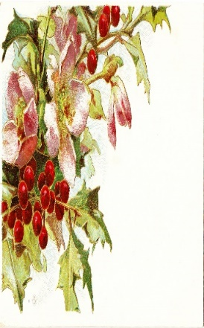](https://www.google.co.uk/url?sa=i&rct=j&q=&esrc=s&source=images&cd=&cad=rja&uact=8&ved=2ahUKEwio3vSv8YDeAhXjzoUKHeAjC9sQjRx6BAgBEAU&url=http://catnipstudiocollage.blogspot.com/2011/10/free-vintage-clip-art-christmas-holly.html&psig=AOvVaw3L0DKxC2dPruQ4pMMQ6l00&ust=1539433076057996)

Whitchurch Association

Christmas Fair

Thursday 5th December

5.00- 7.30pm

£18 PER STALL

We are inviting artisans and craft people to promote their wares at our traditional Christmas craft fair.

Places are limited so please book early to avoid disappointment

Come join us!

For further information please contact:

The Gill Nethercott Centre

01256 896270

gillnethercottcentre@btconnect.com