Frankfurt Christmas Market
Birmingham
Thursday 12th December 2019
8.00am- 6.00pm
£30
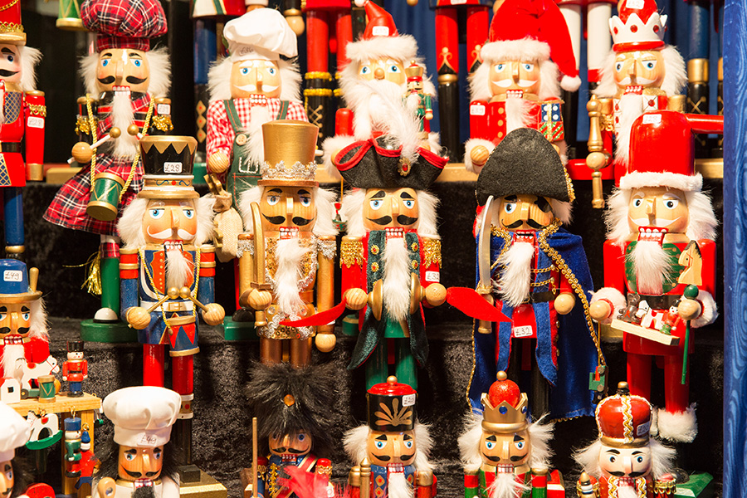
The largest authentic German Christmas market outside of Germany or Austria Birmingham’s Frankfurt Christmas Market offers a large range of traditional good and gifts and a selection of tempting food and drink. Pretzels, schnitzels, bratwursts, and roasted almonds will tempt your tastebuds, all of which can be washed down with gluhwein, weissbeer (wheat beer), or tasty hot chocolate.
For further information please contact:The Gill Nethercott Centre
gillnethercottcentre@btconnect.com 01256 896270

