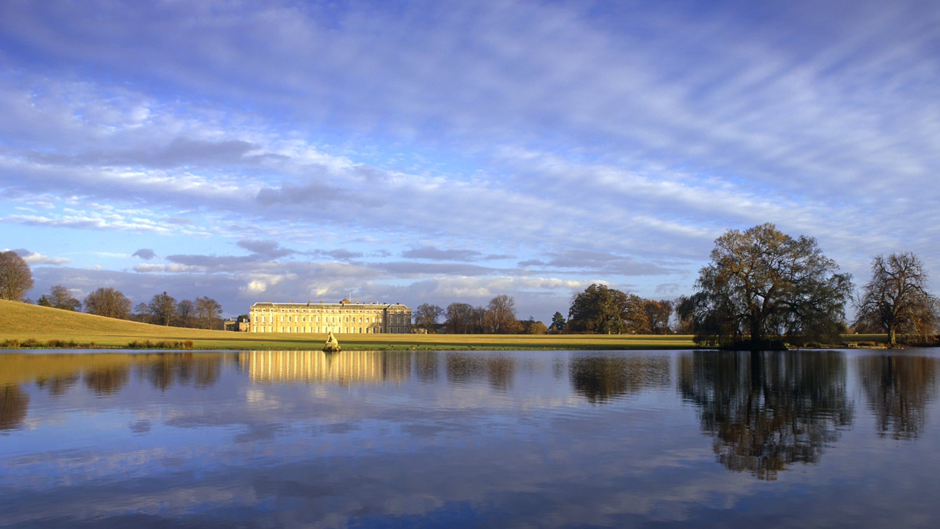

PETWORTH HOUSE
Thursday 5th September
9.00- 6.00pm
£35 non members
£21.50 National Trust Members
Petworth House in the parish of Petworth, West Sussex, England, is a late 17th-century Grade I listed country house, rebuilt in 1688 by Charles Seymour, 6th Duke of Somerset, and altered in the 1870s to the design of the architect Anthony Salvin. It contains intricate wood-carvings by Grinling Gibbons. It is the manor house of the manor of Petworth. For centuries it was the southern home for the Percy family, Earls of Northumberland. Petworth is famous for its extensive art collection made by George Wyndham, 3rd Earl of Egremont, containing many works by his friend J. M. W. Turner. It also has an expansive deer park, landscaped by Capability Brown, which contains the largest herd of fallow deer in England.
Gill Nethercott Centre 01256 896270
gillnethercottcentre@btconnect.com

