The Whitchurch Association
Leeds Castle
28th March 2019
9.00-6.00pm
£38
Let the coach take the pressure of the drive and spend the day at the breath-taking Leeds Castle in Kent. Rising majestically from the moat as it has done for 900 years with 500 acres of beautiful parkland and formal gardens, Leeds Castle is one of the loveliest castles in the world. Your day is your own to wander, eat,
drink, shop and enjoy.
For further information please contact:
The Gill Nethercott Centre
01256 896270 gillnethercottcentre@btconnect.com
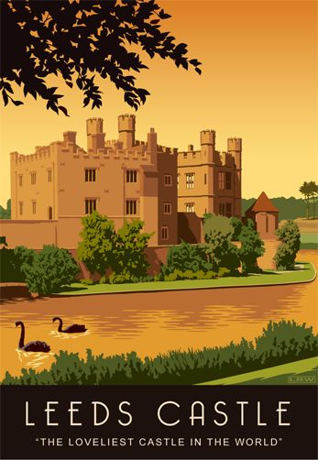

The Whitchurch Association
Leeds Castle
28th March 2019
9.00-6.00pm
£38
Let the coach take the pressure of the drive and spend the day at the breath-taking Leeds Castle in Kent. Rising majestically from the moat as it has done for 900 years with 500 acres of beautiful parkland and formal gardens, Leeds Castle is one of the loveliest castles in the world. Your day is your own to wander, eat,
drink, shop and enjoy.
For further information please contact:
The Gill Nethercott Centre
01256 896270 gillnethercottcentre@btconnect.com

