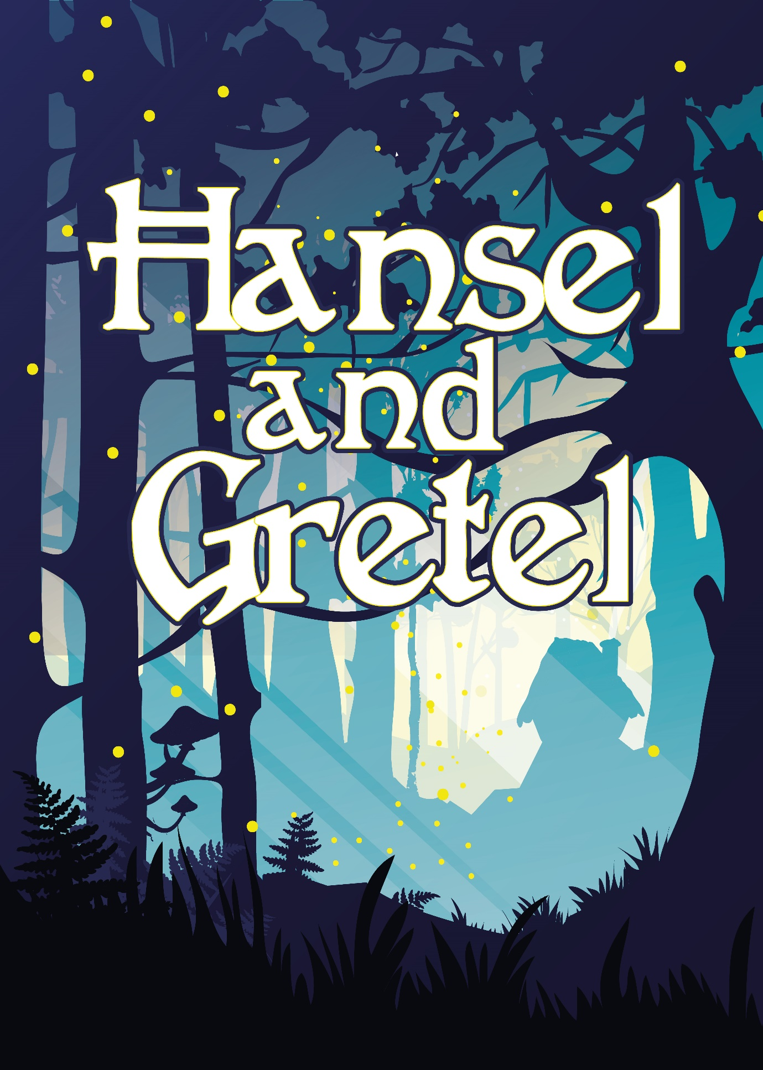

**Sunday 16th December**

**3.00pm- 5.30pm**

**Family 2 adult 3 children £20**

**Adult £8 Child £2**

**Gill Nethercott Centre 01256 896112**

[gillnethercottcentre@btconnect.com](mailto:gillnethercottcentre@btconnect.com)

Not suitable for under 6years