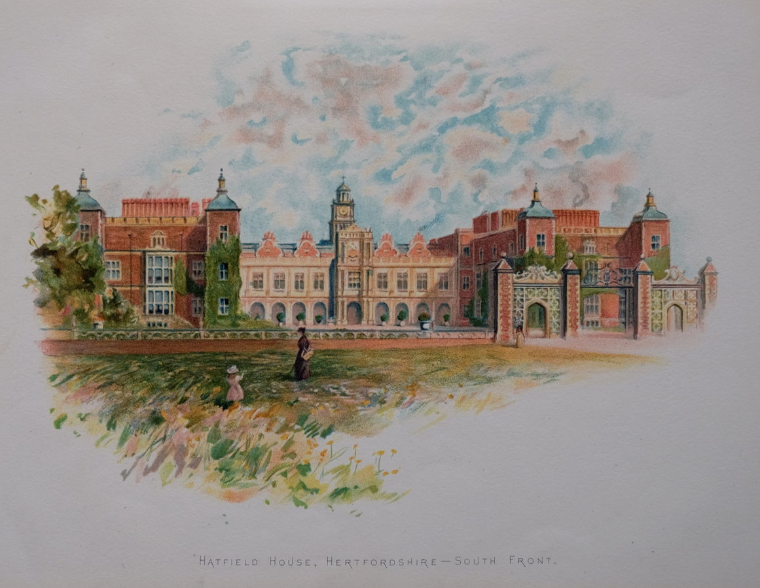
Hatfield House Hertfordshire

Thursday 19th April 2018
9.30- 6.00pm
£35 per head
Hatfield House is the home of the 7th Marquess and Marchioness of Salisbury and has been in the Cecil family for 400 years. The old Palace and grounds had been owned by Henry VIII who had used it as a home for his children, Edward, Elizabeth and Mary.
A superb example of Jacobean craftsmanship
For further information please contact:
The Gill Nethercott Centre
01256 896270
gillnethercottcentre@btconnect.com

